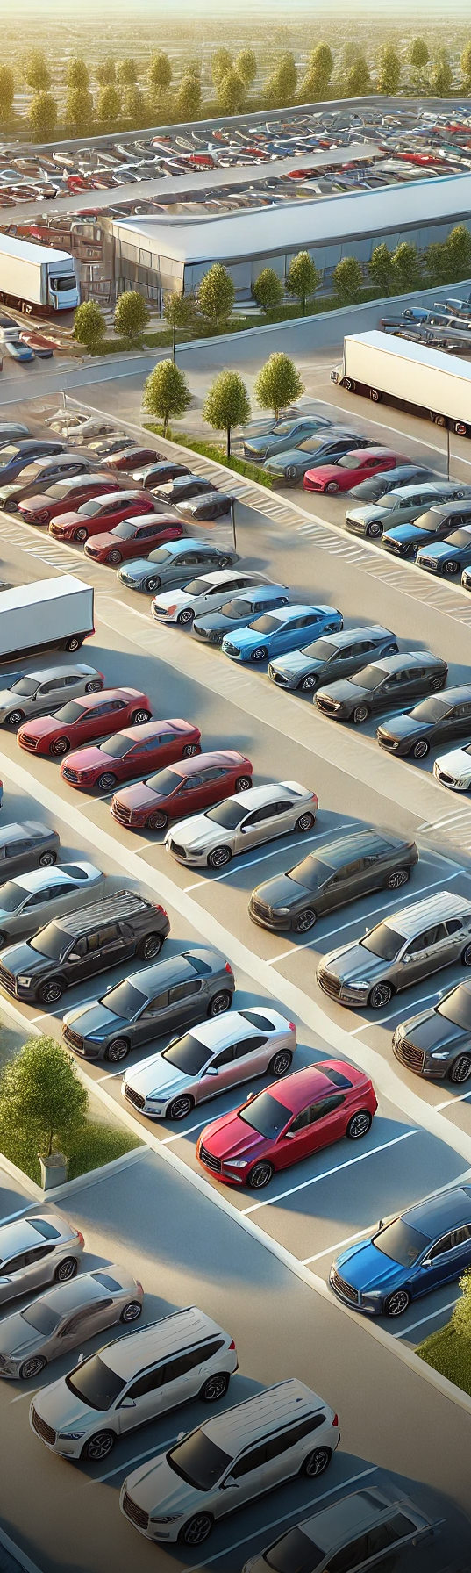

|  |  |
| --- | --- |
|  | **Best**  Car Manufacturers |
| **{d[i,i<3].manufacturer}**  {d[i,i<3].vehicles_sold_2022:formatN(0)} vehicles sold  Top models   * {d[i,i<3].top_models[i]} * {d[i,i<3].top_models[i+1]} |
| {d[i+1,i<3]} |

2022

|  |
| --- |
| **{d[i,i>2].manufacturer}**  {d[i,i>2].vehicles_sold_2022:formatN(0)} vehicles sold  Top models: {d[i,i>2].top_models[i]}, {d[i,i>2].top_models[i+1]} |
| {d[i+1,i>2]} |